For Next Day 2

# 65 Printed as specified

Code

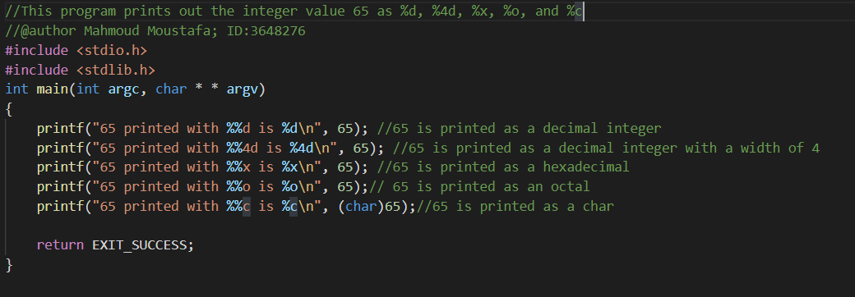

Output

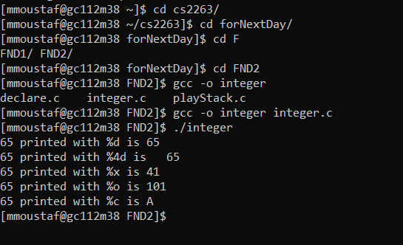

# Sizeof

Code

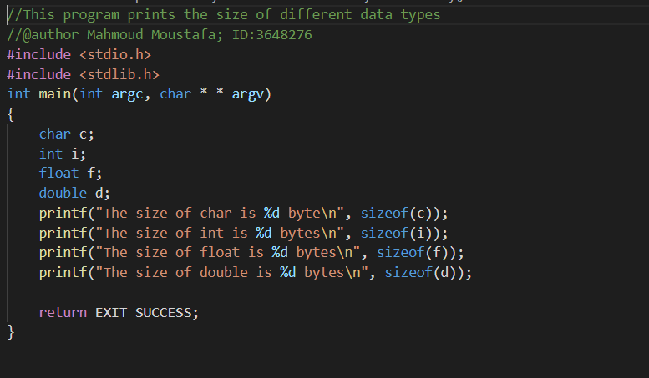

Output

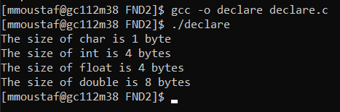

What these values mean

These values are the storage/memory space that different datatypes occupy.

# The minimum and maximum values for a signed int.

Terminal

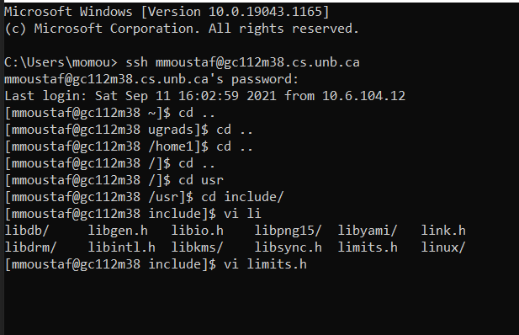

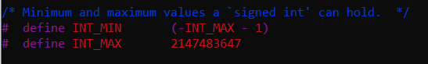

Minimum value for a signed int: -2147483648

Maximum value for a signed int: 2147483647

# playStack

Code

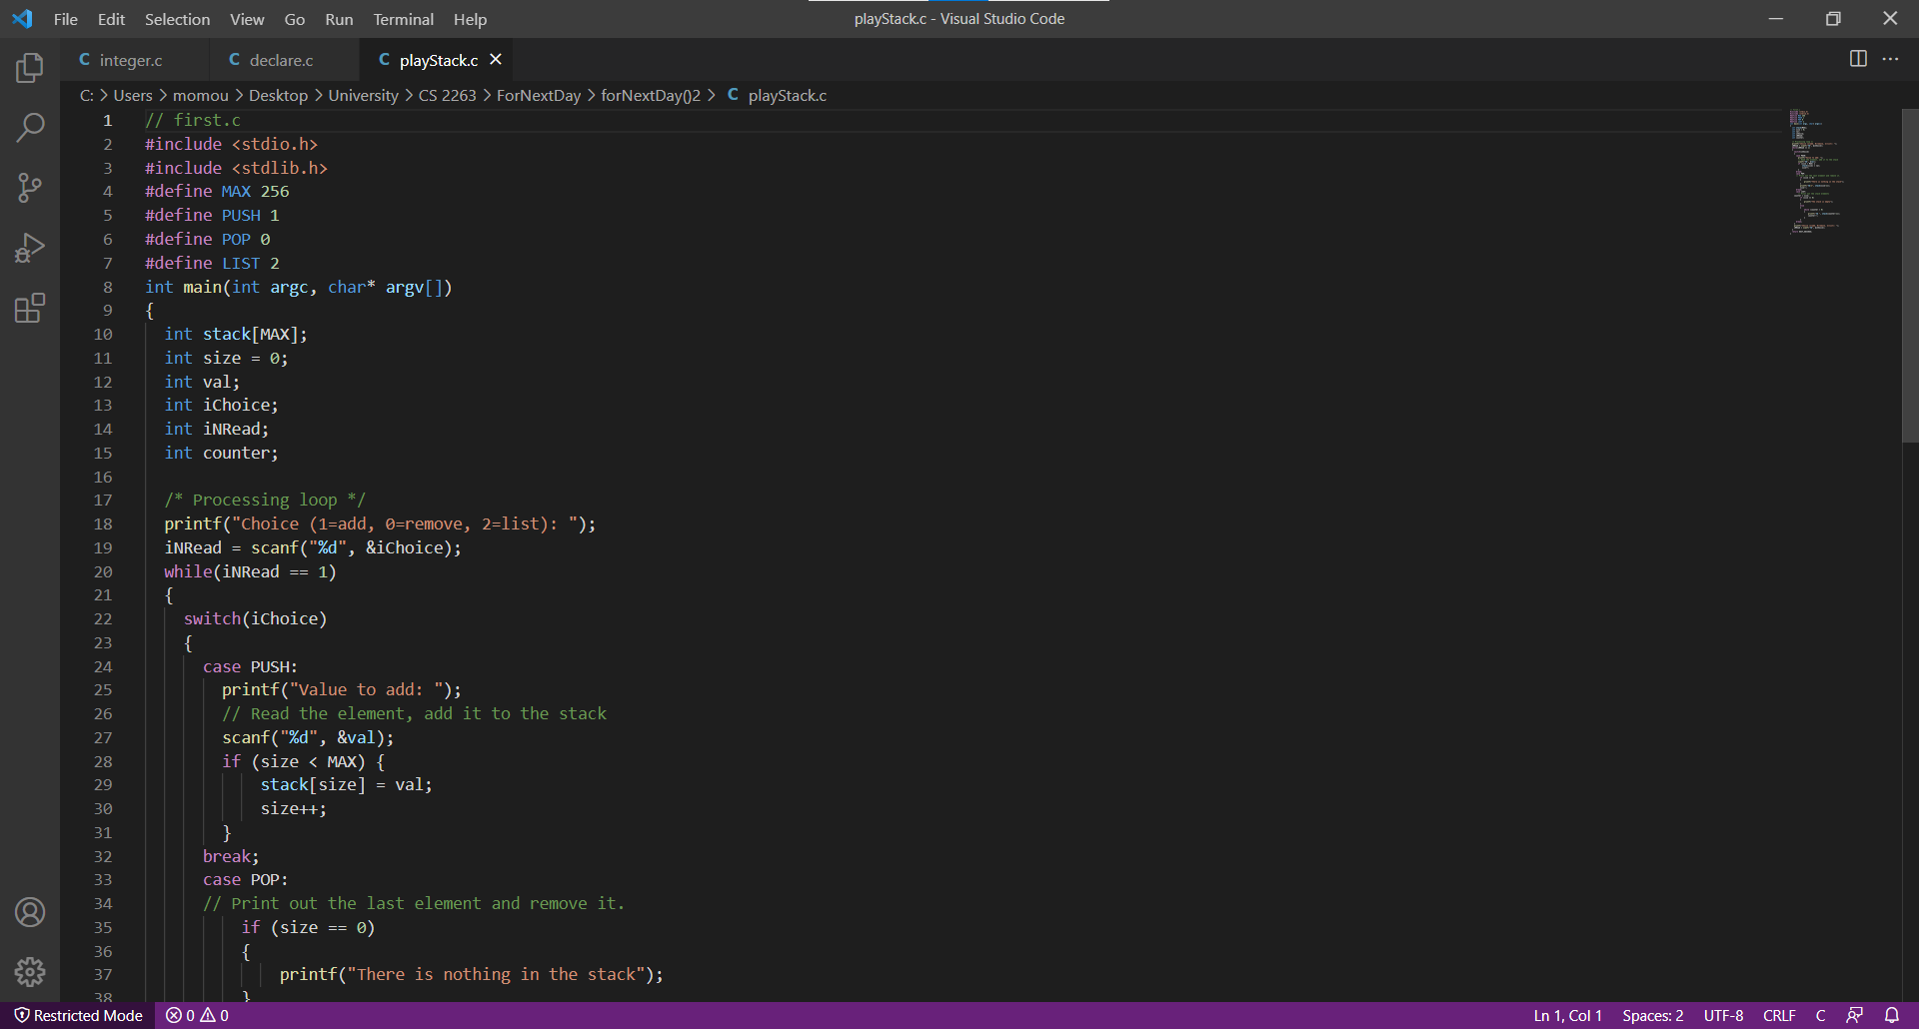

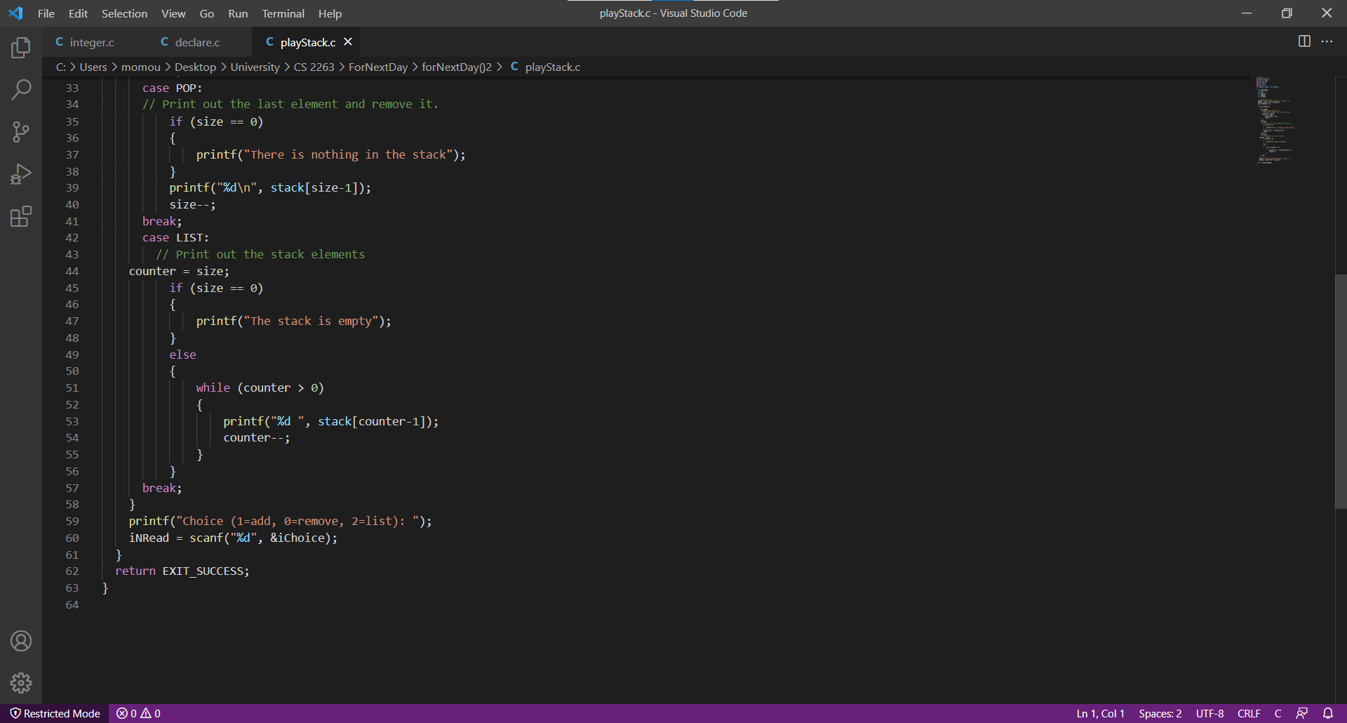

Terminal Output

